## Widen Thermostat Setpoint Deadband.

### Description

It is well understood that for many HVAC systems, significant energy can be saved by increasing the thermostat deadband – the range of zone temperatures at which neither heating nor cooling systems are needed. While saving energy, it is important to acknowledge that large or aggressive deadbands can result in occupant comfort issues and complaints. ASHRAE Standard 55 defines an envelope for thermal comfort, and predictions of thermal comfort should be analyzed to determine an appropriate balance between energy conservation and occupant comfort/productivity. This measure analyzes the heating and cooling setpoint schedules associated with each thermal zone in the model, and widens the temperature deadband of all schedule run period profiles from their existing value by 1.5 degrees F.

### Modeler Description

The measure loops through the heating and cooling thermostat schedules associated each thermal zone. The existing heating and cooling schedules are cloned, and the all run period profiles are then modified by adding a +1.5 deg F shift to the all values of the cooling thermostat schedule and a -1.5 degree F shift to all values of the heating thermostat schedule. Design Day profiles are not modified. The modified thermostat schedules are then assigned to the thermal zone. For each Thermal Zone, ASHRAE 55 Thermal Comfort Warnings is also enabled. Zone Thermal Comfort ASHRAE 55 Adaptive Model 90% Acceptability Status output variables is also added to the model.

### Use Case Types

New Construction, Retrofit, Model Articulation

### Arguments

No arguments

### Initial Condition Message

The initial model contained {X} Cooling Thermostat Schedule and {Y} Heating Thermostat Schedule objects for which this measure is applicable.

### Final Condition Message

The {X} Heating and {Y} Cooling Thermostats schedules for {Z} Thermal Zones were altered to reflect a additional deadband width of 3 Deg F .

Not Applicable Messages

* Write N/A message if model contains only unconditioned thermal zones.

### Warning Messages

### None

### Information Messages

Write info message whenever a Heating or Cooling Thermostat Schedule object is altered. The message should include the name, object type, previous and new attribute value(s).

### Error Messages

N/A

### Code Outline

1. Loop through all Thermal Zones in the model.
   1. Check to see if the zone in unconditioned – if so skip, else:
      1. Retrieve and clone the Cooling Thermostat Schedule object
         1. Loop through all Schedule run Period Profiles.
         2. Adjust each value by a positive 1.5 Deg F
         3. Assign the new schedule object to the thermal zone
         4. Write info message
      2. Retrieve and clone the Heating Thermostat Schedule object
         1. Loop through all Schedule run Period Profiles.
         2. Adjust each value by a negative 1.5 Deg F
         3. Assign the new schedule object to the thermal zone
         4. Write info message
2. Write initial conditions message
3. Write final conditions message

### Tests

Run this model against applicable prototype buildings and test against each qualified object type.

**This measure applies to All Prototype Models:**

1. **Medium Office**

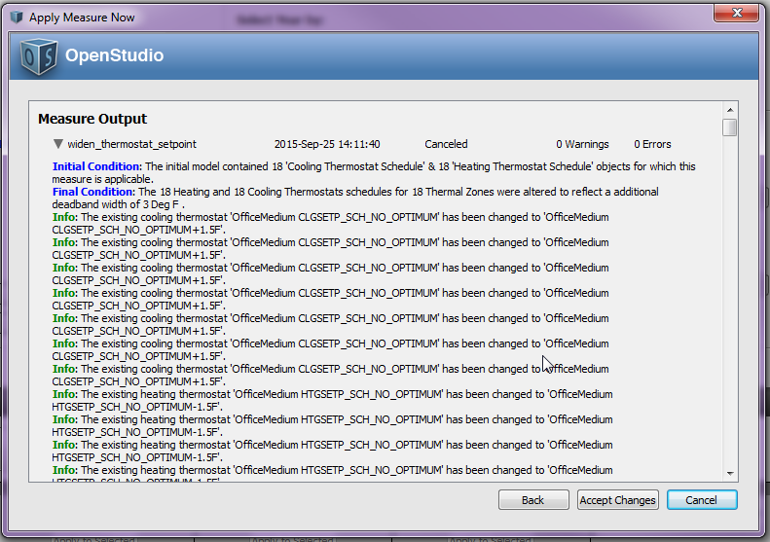

1. **Large Office**

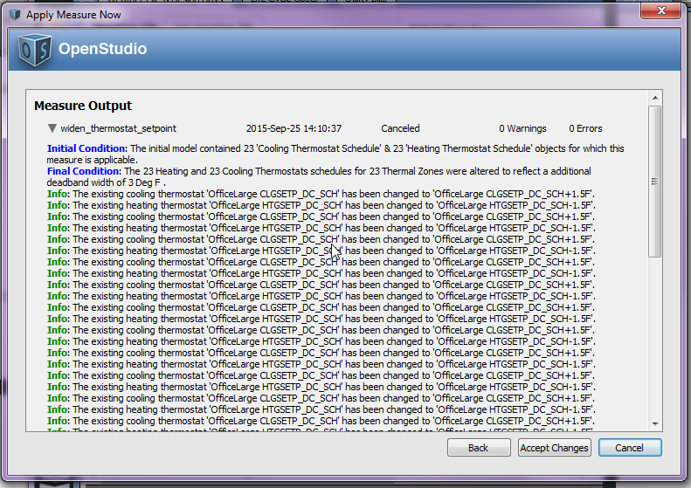

1. **Primary School**
2. **Secondary School**
3. **Outpatient Healthcare**
4. **Large Hotel**

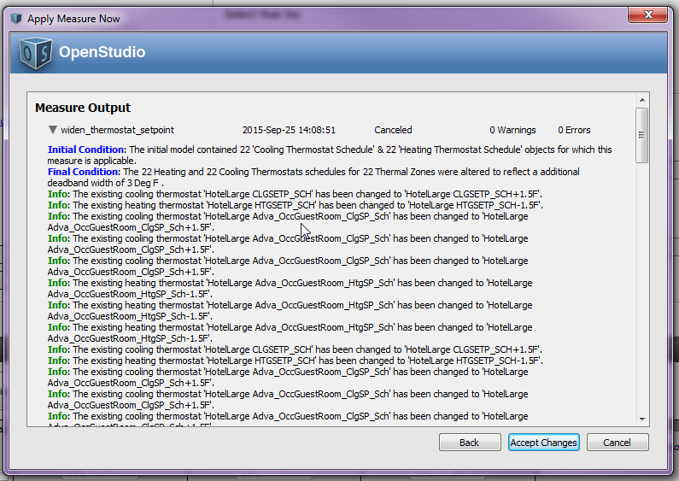

1. **Hospital**
2. **Mid Rise Apartment**
3. **High Rise Apartment**
4. **Small Office**

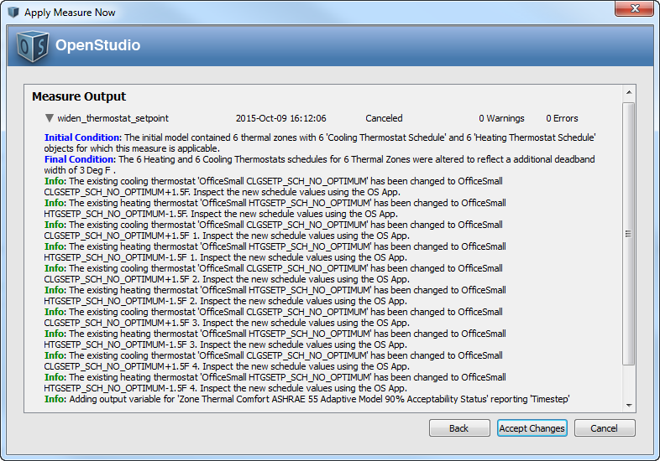

1. **Full Service Restaurant**
2. **Quick Service Restaurant**
3. **Stand Alone Retail**
4. **Strip Mall**
5. **Warehouse (non-refrigerated)**
6. **Small Hotel**

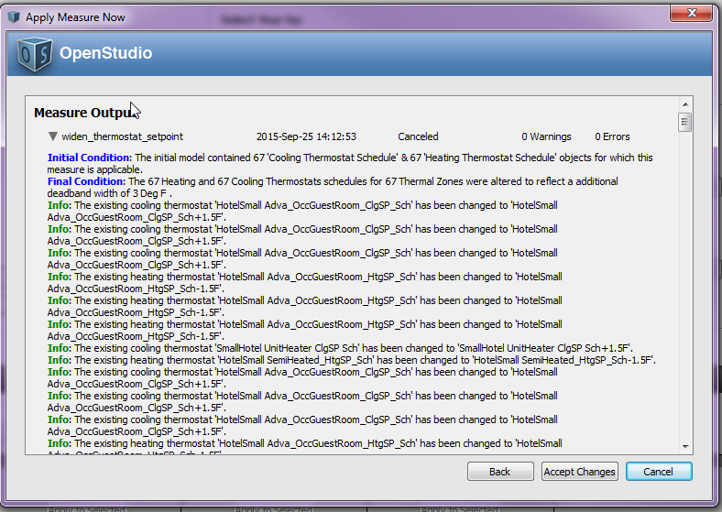

**Test results:**

The delivered measure will include screen shots of the initial, final and info messages as well as screen shots of the OS Application UI showing the object modifications.